Study the space debris impact in the early stages of the KufaSat design

Mohammed Chessab Mahdi
Al-Furat Al-Awsat Technical University -Iraq mchessab@yahoo.com

Abstract

The probability of KufaSat collisions with different sizes of orbital debris and with other satellites which operating in the same orbit during orbital lifetime was determined. Apogee/Perigee Altitude History was used to graph apogee and perigee altitudes over KufaSat lifetime.The change in velocity required for maneuvers needed to achieve atmospheric reentry within 25 years was calculated. The prediction of orbital lifetime of KufaSat using orbital parameters and engineering specifications as inputs to the Debris Assessment Software (DAS) was done, it has been verified that the orbital lifetime will not be longer than 25 years after completion of mission which is compatible with recommendation of Inter-Agency Space Debris Coordination Committee (IADC).
Keywords: Orbital Debris Mitigation, Mission Analysis, DAS, KufaSat, IADC

Introduction

Orbital debris is any man-made object in orbit about the Earth which no longer serves a useful function such as parts of the space rocket, pieces of spaceships or equipment, old unusable satellites, and tiny flecks of paint released by thermal stress or small particle impacts. Space debris is generated in one of three ways: mission operations, accidental, and intentional. [1]
As a result of quickly growth in the number of satellites, the amount of orbital debris is growing rapidly. The estimated numbers of space debris objects in Earth orbit are (29 000) for sizes larger than 10 cm, (670 000) for sizes larger than 1 cm, and more than (170 million) for sizes larger than 1 mm. Any of these objects represents threat to an operational spacecraft in Earth orbit because this debris is travelling at orbital speeds (7-8 km/s).
Depending upon their perigee altitude Satellites and other objects placed in low-Earth orbit will remain in orbit for many years. The higher the altitude, the longer the orbital debris will typically remain in Earth orbit. Debris left in orbits below 600 km normally fall back to Earth within several years. At altitudes of 800 km, the time for orbital decay is often measured in decades [2].
Over the past twenty years, the amount of debris in low-Earth orbit (LEO) has increased rapidly، which led to increase the probability of collision that cause the generation of debris rate exceeds the rate at which debris deorbit, and fall into the atmosphere and burn up. This accumulation creates debris belts that make many orbits unusable. Figure.1 is a computer generated image of objects in low-Earth orbit that are currently being tracked. Approximately 95% of the objects in this illustration are orbital debris, not functional satellites.

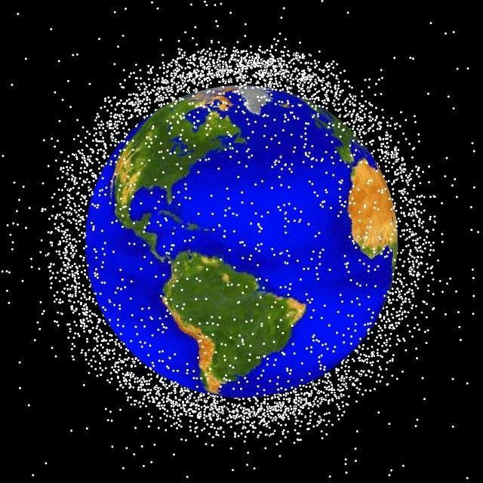
Fig 1 Computer generated image of orbital debris in LEO. Courtesy of NASA

Figure 2, from the NASA Orbital Debris Program Office, shows the number of space objects tracked and catalogued by the US Space Surveillance Network. [3]
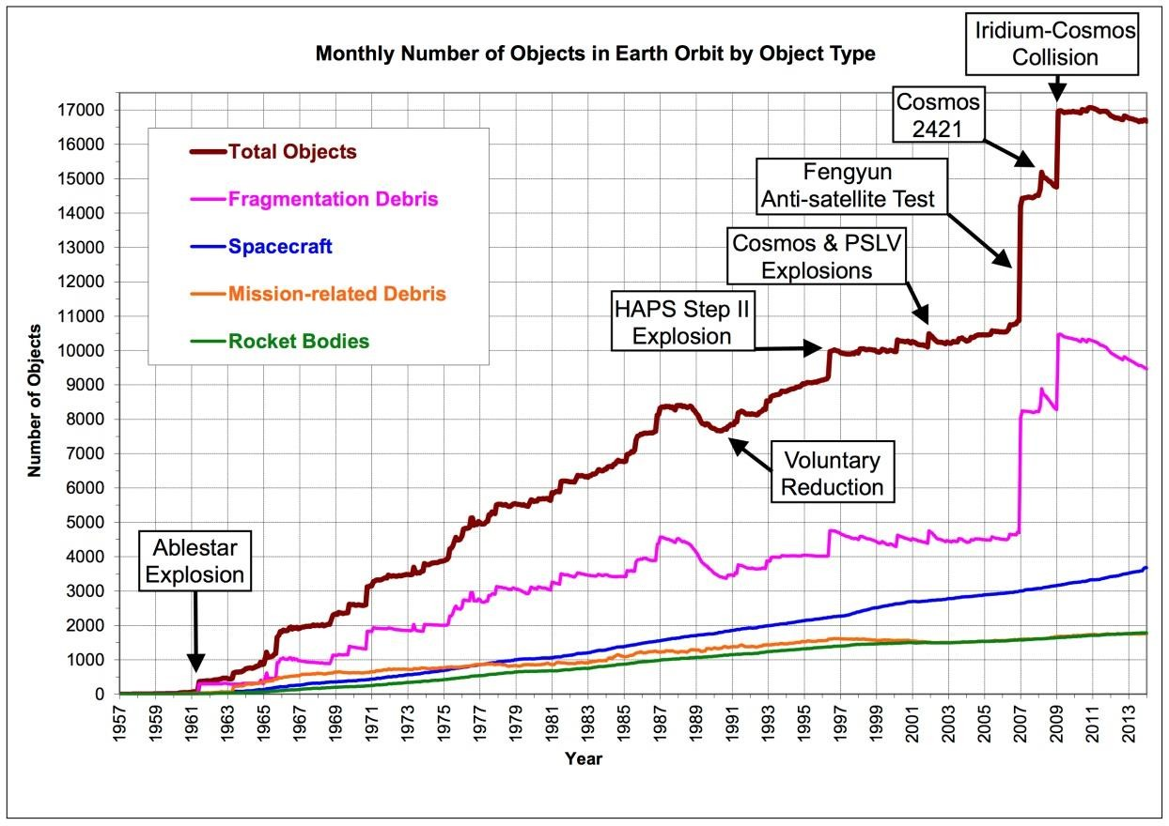
Fig 2 Growth of orbital space object including debris [3]

KufaSat is the first satellite of the University of Kufa, Iraq. It is developed within the framework of program called KufaSat Project, whose goal is to provide hands-on experience to aerospace students in cooperation with another three Iraqi universities. The calculated Keplerian elements for kufaSat are listed in Table.1 [4]
Table 1. KufaSat orbital elements

Field | Value | Unit
Semi-Major Axis (SMA) | 6978 | km
Eccentricity (ECC) | 0 | ----
Inclination (INC) | 97 | deg
Argument of Perigee (AOP) | 150 | deg
Right Ascension of Ascending Node (RAAN) | 0 | deg
True Anomaly (TA) | 10 | deg

Orbital Debris Mitigation Guidelines

Several orbital debris mitigation guidelines have been issued by various organizations
- NASA, U.S Government, the Federal Communications Commission (FCC), and the Inter-Agency Space Debris Coordination Committee (IADC). IADC Space Debris Mitigation Guidelines will be summarized in this work.
The Inter-Agency Space Debris Coordination Committee (IADC) is an international governmental forum for the worldwide coordination of activities related to the issues of man-made and natural debris in space. One of its efforts is to recommend debris mitigation guidelines, with an emphasis on cost effectiveness that can be considered during planning and design of spacecraft and launch vehicles in order to minimize or eliminate generation of debris during operations. [5]
The IADC Space Debris Mitigation Guidelines describe existing practices that have been identified and evaluated for limiting the generation of space debris in the environment. Limitation of debris released during normal operations, minimization of the potential for on-orbit break-ups, post-mission disposal, and prevention of on-orbit collisions represent the overall environmental impact of the missions in this guidelines.

2.1- IADC Mitigation Measures
The main Mitigation measures in IADC guidelines are:
Limit Debris Released during Normal Operations: It is requirement for spacecraft manufacturers to reduce debris generation during normal operations, so all spacecraft must be designed so as not to release debris during normal operations. If that is not possible, the space debris must be limited.
Minimize the Potential for On-Orbit Break-ups: The main factors which cause On- orbit breaks-ups can be prevented using the following measures:
Minimize the potential for post mission break-ups as a result of stored energy
Minimize the potential for break-ups during different phases operation
Avoidance of intentional destruction and other harmful activities
Post Mission Disposal: A spacecraft or orbital stage should be left in an orbit in which, using an accepted nominal projection for solar activity, atmospheric drag will limit the orbital lifetime after completion of operations. To avoid or minimize the risk of collisions a spacecraft with orbital debris the Inter-Agency Space Debris Coordination Committee (IADC) recommended that the appropriate lifetime limit is 25-year.
Prevention of On-Orbit Collisions: In developing the design and mission profile of a spacecraft or orbital stage, a program or project should estimate and limit the probability of accidental collision with known objects during the spacecraft or orbital stage’s orbital lifetime.[6]

Debris Assessment Software (DAS)

The Debris Assessment Software (DAS) version 2.0.2 which is designed to assist NASA programs in performing orbital debris assessments (ODA), as described in NASA Technical Standard 8719.14, (Process for Limiting Orbital Debris) is used in this work. DAS 2.0.2 uses the NASA propagator “PROP3D” which is designed to maintain integration accuracy over long propagation periods with reasonable computation speed. Atmospheric drag, Solar and Lunar gravity, solar radiation pressure, and Earth’s gravity field with Zonal harmonics (J2, J3, and J4) are the perturbations included in the DAS orbit propagator. The atmospheric model used in DAS was the Jacchia 1976 Standard Model. The coefficient of drag is assumed to be
2.2 and the coefficient of reflectivity (for the solar radiation pressure perturbation) is assumed to be 1.25. The major functions of DAS are divided into three sections: mission editor, requirement assessments, and associated science and engineering utilities. The mission information must be entered into the mission editor.Requirement assessments section of DAS includes routines to assess the mission’s compliance with each NASA debris limiting requirement. Science and engineering utilities provide a number of functions useful for mission planning and allow analyzing some aspects of orbit/mission design. [7]

Simulation and results

Science and engineering utilities include six categories: on-orbit collision, analysis of postmission disposal maneuver, orbit evolution analysis, delta-V postmission maneuver analysis, orbit to orbit transfer, and other utilities [7].
On-Orbit Collisions
Probability of debris impacts versus a verity of factors can be graphed to provide a visual aid. Figures (3, 4, and 5) are the results of the three contour plotting tools which are available within this category. These figures explain the relations between Debris Impacts vs. Orbit Altitude, Debris Impacts vs. Debris Diameter, and Debris Impacts vs. Date respectively. These utilities assist in the assessment of compliance with Requirement, to (limit the probability of operating space systems becoming a source of debris through collisions with orbital debris or meteoroids).

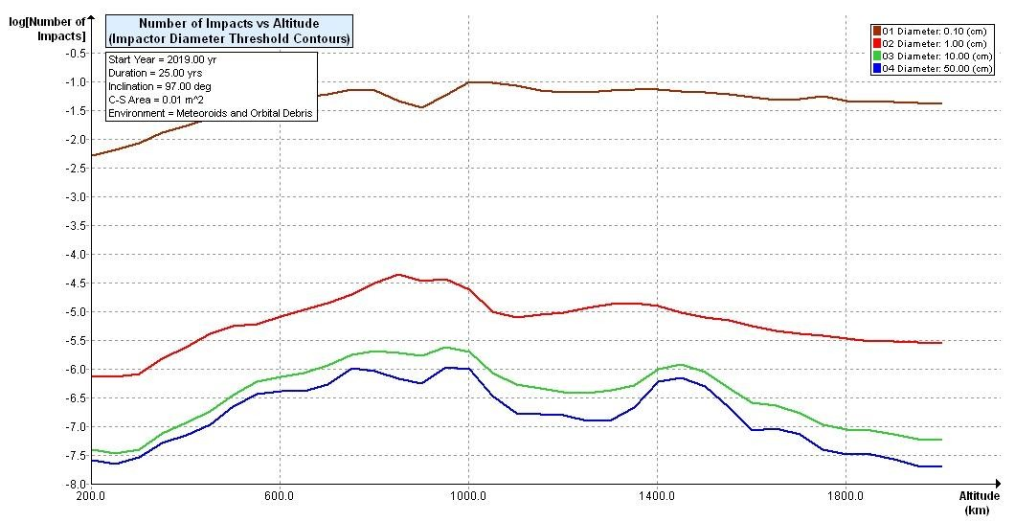
Fig (3) Debris Impacts vs. Orbit Altitude
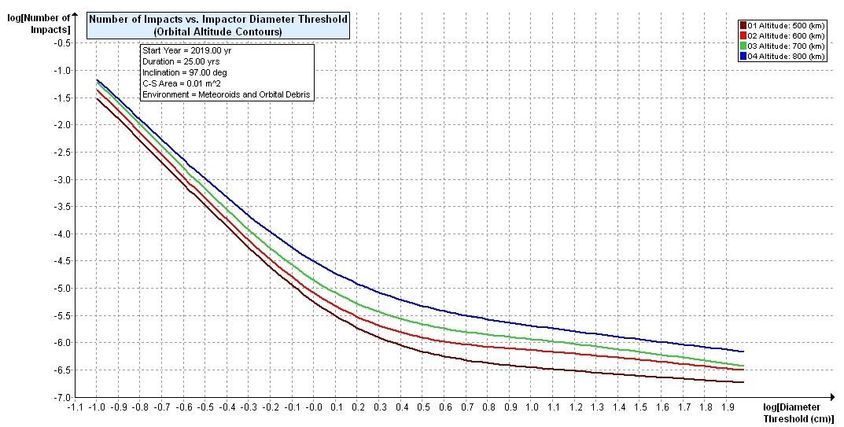
Fig (4) Debris Impacts vs. Debris Diameter
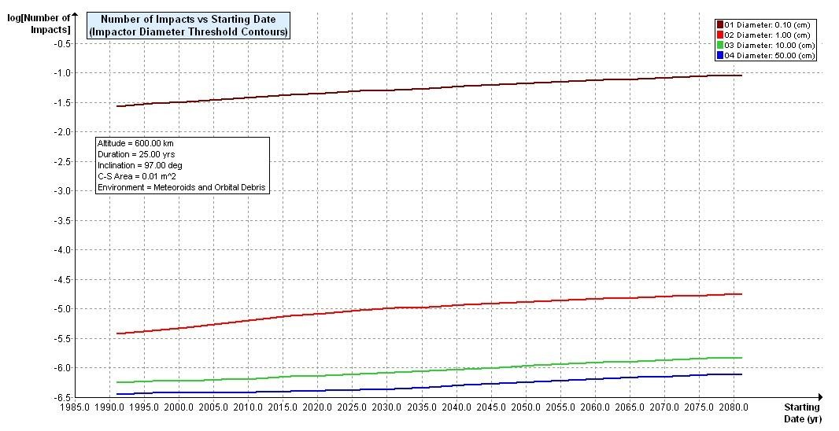
Fig (5) Debris Impacts vs. Date

Analysis of Postmission Disposal Maneuvers
Disposal by Atmospheric Reentry utility plots contours of Delta-V corresponding to the Delta-V required moving from LEO to a decay orbit with specified lifetime. This may aid in determining the cost of deorbit maneuvers. Figure (6) explain disposal by atmospheric reentry. These utilities assist in the assessment of compliance with Requirement the (postmission disposal of space structures).
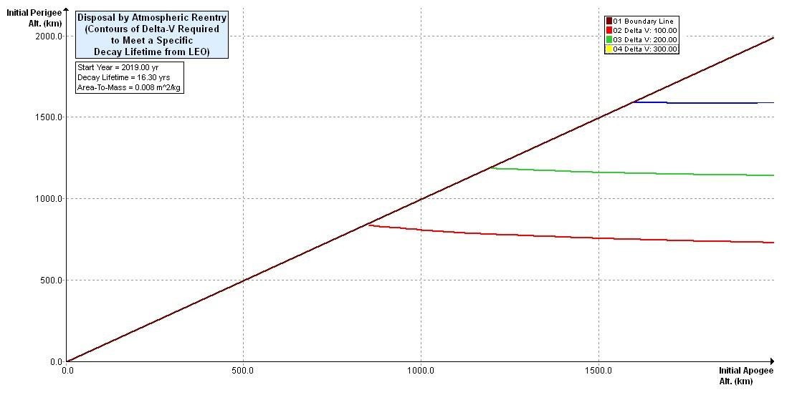
Fig (6) Disposal by Atmospheric Reentry

Orbit Evolution Analysis
Two utilities are available within this group. Apogee/Perigee Altitude History which is used to graph apogee and perigee altitudes over object lifetime as shown in Figure
(7) and Orbit Lifetime/Dwell Time which calculates the Orbital Lifetime and LEO Dwell Time of an object in a specified orbit. These utilities assist in the assessment of compliance with Requirement, the (postmission disposal of space structures). For KufaSat it is found that the calculated Orbital Lifetime from year 2019 as a start year equal to 16.356 years. The year that the object either reentered or exceeded the propagation time limit is 2035. Table.2 shows the effect of varying the area to mass ratio on orbital lifetime of KufaSat with assuming 2019 is the start year.

Table.2 Area to mass ratio vs. Orbital lifetime

Area to mass ratio | Orbital lifetime | Last year of propagation
0.005 | 26.683 | 2045
0.006 | 24.241 | 2043
0.0076923 | 16.350 | 2035
0.009 | 15.086 | 2034
0.010 | 14.286 | 2033
0.015 | 6.779 | 2025
0.020 | 5.235 | 2024
0.030 | 4.233 | 2023
0.100 | 2.689 | 2021
0.500 | 1.884 | 2020

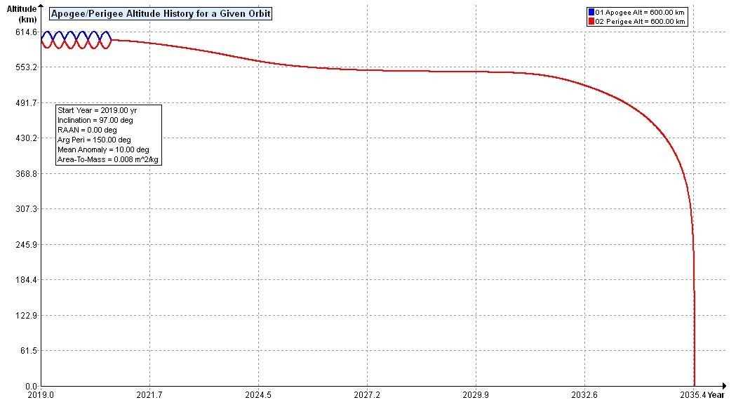

Fig (7) Apogee/Perigee Altitude History for a Given Orbit

Delta-V for Postmission Maneuver
These utilities calculate the change in velocity required for maneuvers needed to achieve atmospheric reentry within 25 years. Two utilities are available within this group.
Delta-V for Decay Orbit Given Orbital Lifetime: plots area-to-mass ratio contour points corresponding to the Delta-V required moving an object, with a specified orbital lifetime, from an initial circular LEO orbit to a decay orbit. The plot allows exploring the cost of deorbiting a vehicle. Figure (8) represent the output of this utility for KufaSat.
Delta-V for Decay Orbit Given Area-To-Mass: plots lifetime contour points corresponding to the Delta-V required moving an object, with a specified area- to-mass ratio, from an initial circular LEO orbit to a decay orbit. The plot allows exploring the cost of deorbiting a vehicle over a range of decay lifetimes. Figure
(9) represent the output of this utility for KufaSat.
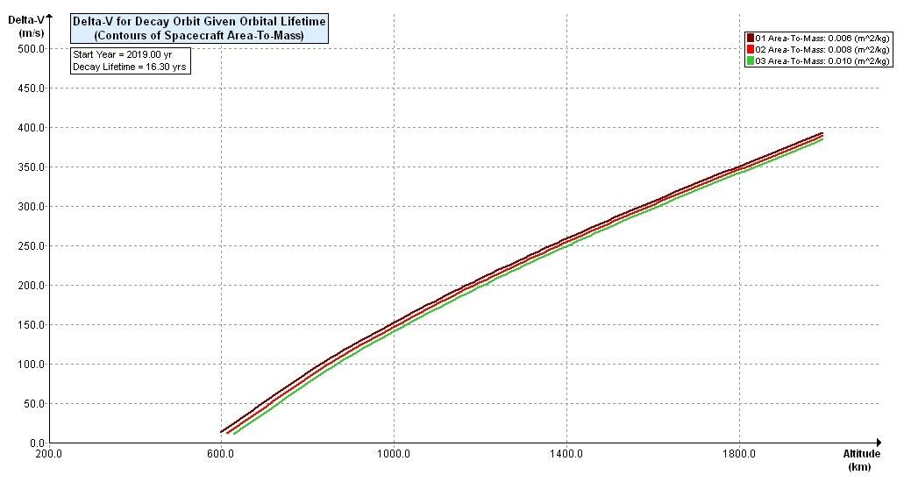
Fig (8) Delta-V for Decay Orbit Given Orbital Lifetime

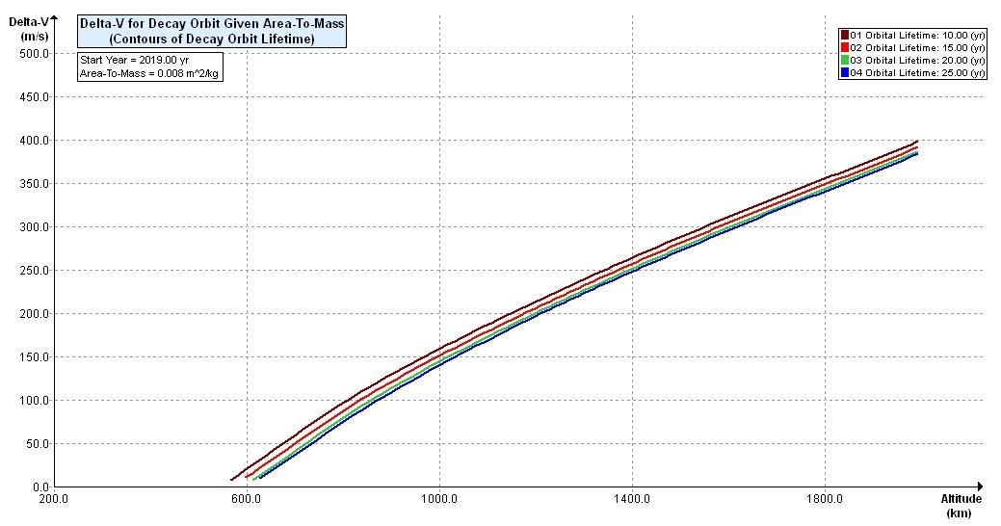

Fig (9) Delta-V for Decay Orbit Given Area-To-Mass

Conclusion

Space debris mitigation is required for each space mission to ensure of compliance with requirements and standards in addition to ensure that the spacecraft can resist the space debris environment during the mission lifetime. One of important aspect is estimation and limitation the probability of collision with known objects during orbital lifetime which cause loss of control to prevent post-mission disposal. KufaSat mission analysis was conducted using the Debris Assessment Software (DAS). By this software the probability of collisions with different sizes of known objects during orbital lifetime of KufaSat was determined.
By using orbital parameters and engineering specifications of KufaSat as inputs to DAS it has been verified that the orbital lifetime will not be longer than 25 years after completion of mission.

References

[1] International Space University, Florida Institute of Technology "Operations and Service Infrastructure for Space" Melbourne, Florida, USA, SSP 2012
[2] NASA Orbital Debris program Office "Orbital Debris Frequently Asked Questions, Available on http://orbitaldebris.jsc.nasa.gov/faqs.html#3
[3] Orbital Debris Quarterly News, Volume 18, Is-sue 1, NASA JSC, January 2014 [4] Mahdi M. Chessab "Orbit Design and Simulation for KufaSat Nano-Satellite"
Artificial Satellites Journals, Vol. 50, No. 4 – 2015
[5] Inter-Agency Space Debris Coordination Committee (IADC) Website,
Available on http://www.iadc-online.org/index.cgi?item=home
[6] Inter-Agency Space Debris Coordination Committee, “IADC Space Debris Mitigation Guidelines, Revision 1”, IADC-02-01, September 2007.
[7] NASA," Debris Assessment Software User’s Guide Version 2.0" Lyndon
B.Johnson Space Center, Houston, Texas 77058, 2012.

